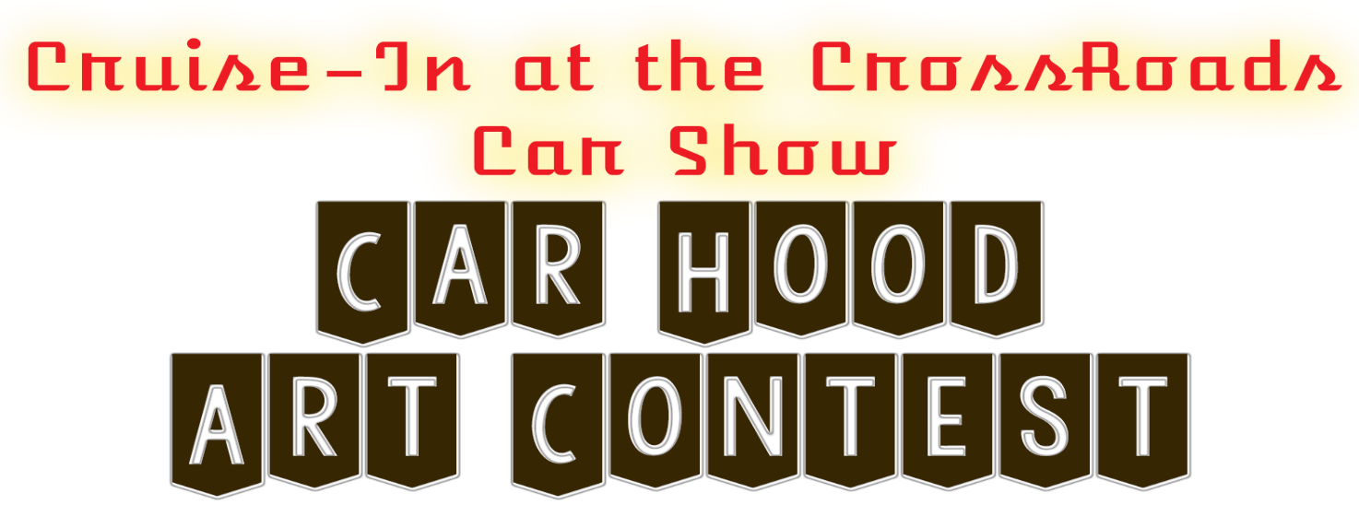
Sponsored by
June 19, 2019 at the Belleville City Park
Pre-Register by June 15th
Call 785-527-2827 or stop at Stephens Collision & Glass 1513 15th Street
Open to all ages and skill levels * Registration--$20 includes Hood
Entry check-in at the Band Shelter from 10:00-10:30 AM on June 19th
Judging opens at 11:30 AM until 2 PM —Winners will be announced at 3 PM
Rules:
- Any medium of art is accepted as long as all the components are attached to the car hood. No large displays. Must be one complete piece.
- Stephens Collision will provide hoods upon registration. Entrants may find their own hood if they prefer. Registration fees go to Cruise-In at the Crossroads.
- Event Administrators reserve the right to refuse any entry based on content such as violence, drugs, illegal activities, gore, discriminatory images, or obscenities. Any such entries will be asked to leave.
- First and Second Place are determined by outside judges
- Attendees and Participants of the Car Show will choose the people’s choice winner by popular ballot. One ballot per person.
- Entries must be picked up by 4:00 PM on the day of the contest.
- Cruise-in at the Crossroads, Belleville Chamber and Main Street, and Stephens Collision and Glass are not responsible for entries left past 4:00 PM
- Prizes:
  - Cash Prizes will be given for 1st and 2nd place.
  - People Choice Award
  - Entrants do not have to be present to win
_________________________________________________________________________________________________
Car Hood Art Contest Pre-Registration: Return to Stephens Collision & Glass, 1513 15th Street, 785-527-2827

Entrant Name(s): ________________________Parent Name (if under 18): ____________________________________________
Phone: ______________ Address: ____________________________________ E-mail: __________________________________
Name of the Entry (if applicable): ___________________________Permission to post photos and names of entry/entrants on Stephens Collision Social Media and/or Website: Yes____ No____ Signed: _____________________________________________
Received by: ______ Registration fee paid: ______ Hood Picked Up: _______
Entry Number: ________ Placing: __________Prize Delivered ___________

